Kaylin Shioshita

Advanced Mobile App Development

Project 1 Milestone 1

For Project 1, I want to create a skin care journal that will let users track the health of their skin and view trends at a glance. The initial screen will be a monthly view and each day that the person added an entry will be color coded depending on their skin’s condition. The user will add data to a particular day by selecting the day of the month they want. When they want to add data, a new view will appear and give them options to rate their skin health overall and then select buttons that will describe the steps of their routine they did that day. I also will have a switch that will allow users to select if it was their morning or evening routine. I want to use image buttons because it will allow the user to easily and quickly add steps to their routine. After saving data the user can see the data entered on a particular day by clicking on it and another view will appear with the information they added, which they will also be able to edit. Also, when doing initial research, I found that there in an Android app called My Daily Skincare but it’s not available on iOS and it’s overly complicated. I tried using it but I didn’t like having to manually type out each name of the products I use and there were poor uses of sliders and scales that didn’t make sense. I want to try to simplify my design so that users will actually want to enter their data every day.

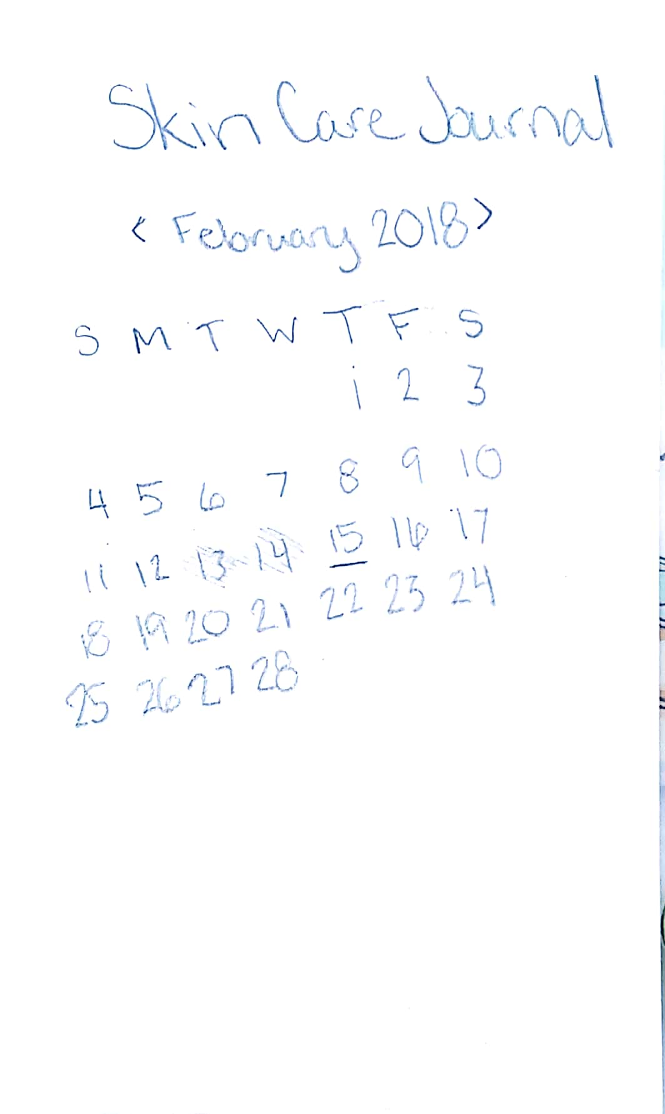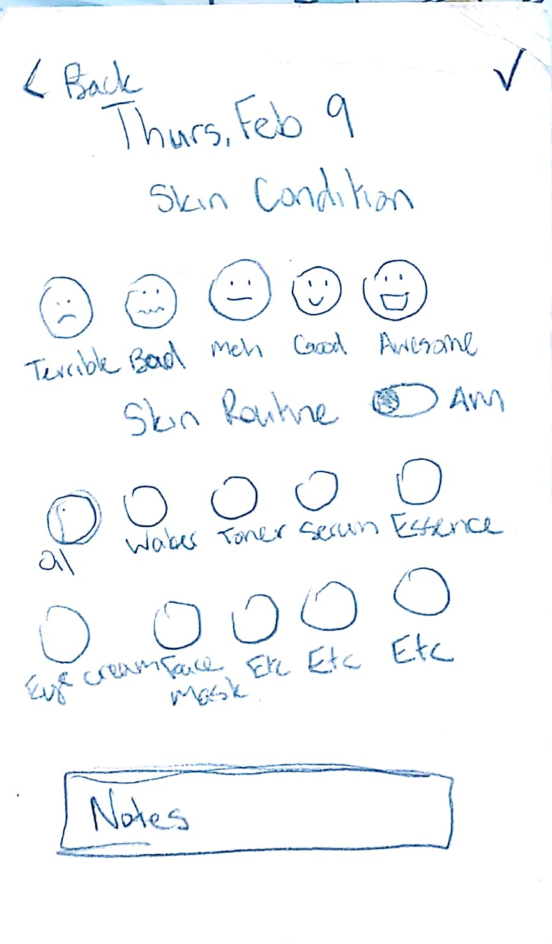 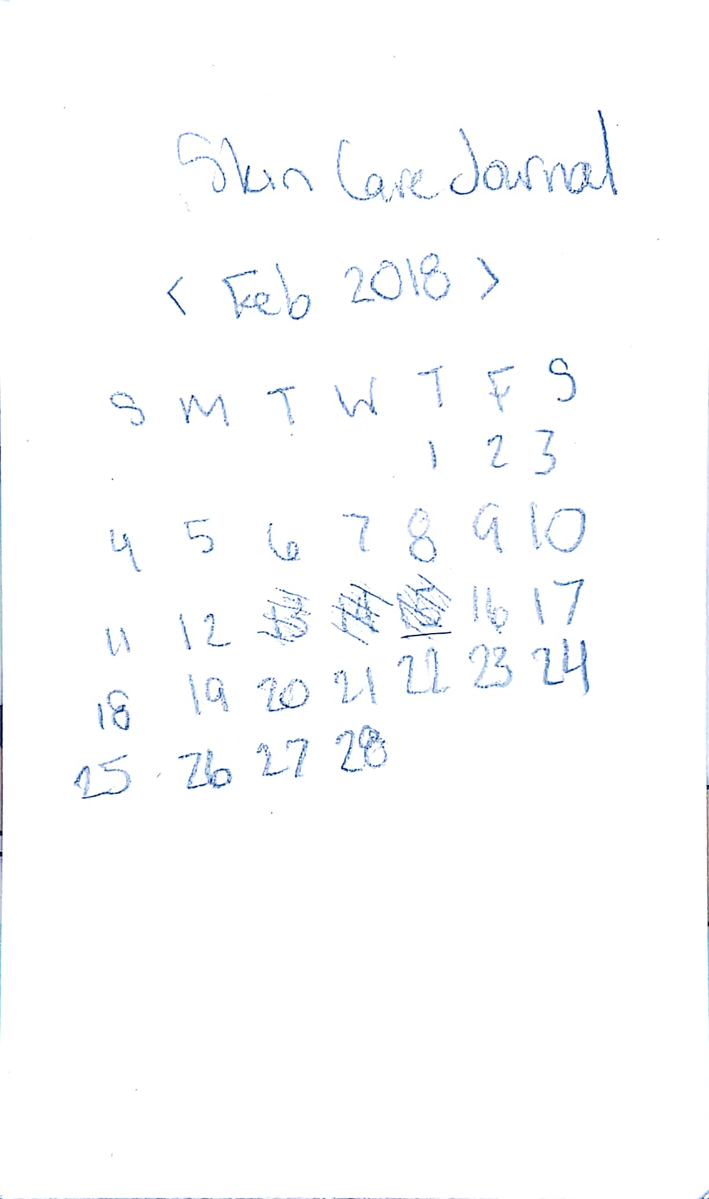

Initial View Adding Daily Data

Viewing Daily Data After entry is added